Wind Power ForEcasting using Deep learning

A Project Report

Submitted for the Partial Fulfilment of the Requirements for the Degree of

BACHELOR OF TECHNOLOGY

IN

Electrical Engineering

submitted by

Pawan Kumar Saini (16EE01042)

under the guidance of
Dr. Chandrashekhar Narayan Bhende



School of Electrical Sciences
Indian Institute of Technology Bhubaneswar
May 2020
Indian Institute of Technology Bhubaneswar
CERTIFICATE
Certified that the project work entitled Wind Power Forecasting using Deep Learning was carried out by Mr. Pawan Kumar Saini, Roll No. 16EE01042, a bonafide student of Indian Institute of Technology Bhubaneswar in partial fulfillment for the award of Bachelor of Technology in Electrical Engineering during the year 2019-20. It is certified that all corrections/suggestions indicated for internal assessment have been incorporated in the report deposited in the departmental library. The project report has been approved as it satisfies the academic requirements in respect of project work prescribed for the said degree.

Dr. Chandrashekhar Narayan Bhende
Name and Signature of the Supervisor -1

Prof. N. C. Sahoo
Name and Signature of the Head of the School

Project evaluation date: 27 May 2020  Dr. Dipankar De  Internal Examiner-1 | Dr. S.R. Samantaray  External Examiner-2

Declaration

We declare that this written submission represents our ideas in our own words and where others' ideas or words have been included, we have adequately cited and referenced the original sources. We also declare that we have adhered to all principles of academic honesty and integrity and have not misrepresented or fabricated or falsified any idea / data / fact / source in my submission. We understand that any violation of the above will be cause for disciplinary action by the Institute and can also evoke penal action from the sources which have thus not been properly cited or from whom proper permission has not been taken when needed.

PAWAN KUMAR SAINI
(Name of the student)

16EE01042
(Roll No.)

Date: 20 May 2020
DEDICATed

Dedicated to My Family, Friends and Teachers.

ACKNOWLEDGMENT

I take this opportunity to express a deep sense of gratitude towards my guide Dr. Chandrashekhar Narayan Bhende, for providing excellent guidance, encouragement and inspiration throughout the project work. Without his invaluable guidance, this work would never have been a successful one. I would also like to thank all my classmates for their valuable suggestions and helpful discussions.

PAWAN KUMAR SAINI
(Name of the student)

16EE01042
(Roll No.)

Date: 20 May 2020

TABLE OF CONTENTS

ABSTRACT | 3
LIST OF FIGURES | 4
LIST OF TABLES | 5
LIST OF ABBREVIATIONS | 6
- INTRODUCTION | 7
- EVALUATION OF PARAMETERS AFFECTING WIND TURBINE POWER GENERATION | 9
- PARAMETERS THAT AFFECT WIND POWER | 9
- WIND SPEED AND CONSISTENCY: | 9
    - HEIGHT OF TOWER AND INSTALLATION: 9
    - DENSITY OF AIR: 10
    - ROTOR DIAMETER 10
    - TREND and TECHNOLOGICAL BREAKTHROUGHS 10

  - WIND TURBINE PARAMETERS: 10
    - CHOICE OF THE PITCH ANGLE: 10
    - TIP SPEED RATIO: 11
    - COEFFICIENT OF POWER 11
    - TORQUE SPEED CHARACTERISTICS 11
- FORECASTING APPROACHES: 13
  - LONG SHORT-TERM MEMORY 13
  - LSTM PREDICTION MODEL: 15

- SIMULINK BLOCK DIAGRAM OF WIND POWER GENERATOR: 16

- DATA-SET FOR LSTM EXPERIMENTS 18

- RESULTS: 19
  - ESTIMATION: 19
    - 70-30 TRAIN TEST BATCH 19
    - 60-40 TRAIN TEST BATCH 20
  - PREDICTION USING ONE BY ONE POINT: 20
    - PREDICTION OF 12 HOURS 21
    - PREDICTION FOR 24 HOURS 22
    - PREDICTION FOR 48 HOURS 23
    - PREDICTION FOR 1 WEEK 23
    - PREDICTION FOR 12 HOURS WITH MODEL OPTIMIZATION 24
    - PREDICTION FOR 24 HOURS WITH MODEL OPTIMIZATION 24
    - PREDICTION FOR 48 HOURS WITH MODEL OPTIMIZATION 25
  - POWER PREDICTION FOR NEXT KTH TIME INTERVAL AT A TIME. 25
    - POWER PREDICTION FOR NEXT 24 HOURS 25
    - FUTURE POWER PREDICTION FORNEXT 48 HOURS26
    - FUTURE POWER PREDICTION FOR NEXT 1 WEEK 26
    - FUTURE POWER PREDICTION FORNEXT 1 MONTH27

- FRONT END DESIGN: 28
  - FUNDAMENTALS OF TKINTER 28
  - TKINTER WIDGETS 29
  - LABEL WIDGET: 29
  - BUTTON: 30
  - BLOCKS: 30

- CONCLUSION 32

- CURRENT RESEARCH ACTIVITIES AND FUTURE ADVANCES 33

- BIBLIOGRAPHY 34

ABSTRACT
Wind generation is different from conventional heat generation due to wind storm. Thus wind power prediction plays a major role in addressing the challenges of estimation of the demand for information on any electrical system, if uncertainties related to wind farm output can be confirmed. Accurate wind power forecast reduces the need for additional measuring power and energy savings to integrate wind power. Wind power forecasting tools enable better deployment, and unit wind energy commitment planning, hydro and energy storage and more competitive trade as wind power goes up and down the grid. This report presents an in-depth review of current trends and developments in wind power forecasting. First of all, estimation methods for numerical values ​​from global to local scales, climatic collections, stair climbing and rate increases are discussed. Subsequently mathematical and machine learning methods are described that is model for wind power prediction based on the Long Short-term Memory model, one of the deep learning methods. Deep learning is in line with the tendency for Big Data is also capable of reading and adapting to large amounts of data. Principal component analysis (PCA) is used select input samples and reduces the size of the input variance of the LSTM forecasting model based on the Numerical weather forecast data (NWP). Simulation results show that, compared with BP neural network and Support Vector Machine Machine(SVM), LSTM prediction model has high predictive accuracy and great engineering power applications. It is effective to use a short-term memory model in the wind power forecasting field. Then the strategies used for the estimation and uncertainty analysis of the climate are reviewed, and the comments of various methods over the period of different forecasts are examined. Finally, current observational activities, challenges and future developments are explored.
LIST OF FIGURES
FIGURE NO | FIGURE TITLE | PAGE NO
Figure 1.1: | Block Diagram of Wind plant | 8
Figure 2.1: | Output power for different value of wind speed(m/s) | 12
Figure 3.1: | LSTM model | 14
Figure 3.2: | LSTM block chain diagram | 15
Figure 4.1: | Simulation diagram of DFIG turbine | 16
Figure 4.2: | Current, Voltage and output power of simulation | 17
Figure 6.1: | Data estimation for 70-30 ratio | 19
Figure 6.2: | Data estimation for 60-40 ratio | 20
Figure 6.3: | Power prediction for 12 hours | 21
Figure 6.4: | Power prediction for 24 hours | 22
Figure 6.5: | Power prediction for 48 hours | 23
Figure 6.6: | Power prediction for 1 week hours | 23
Figure 6.7: | Power prediction for 12 hours with more accuracy | 24
Figure 6.8: | Power prediction for 24 hours with more accuracy | 24
Figure 6.9: | Power prediction for 48 hours with more accuracy | 25
Figure 6.10: | Power prediction for 24 hours | 25
Figure 6.11: | Power prediction for 48 hours | 26
Figure 6.12: | Power prediction for 1 week | 26
Figure 6.13: | Power prediction for 1 month | 27
Figure 7.1: | block diagram for Creating a GUI using tkinter | 28
Figure 7.2: | Block diagram for Creating a Tkinter Widgets | 29
Figure 7.3: | Front End View of Project | 30
LIST OF TABLES
TABLE NO | TABLE TITLE | PAGE NO
Table 5.1: | Snapshot of Data-set | 18

List of ABBREVIATIONS
NWP | Numerical Weather Prediction
ANN | Artificial Neural Input Network
LSTM | Long Short Term Memory
RNN | Recurrent Neural Network.
GUI | Graphical User Interface.
SVM | Support Vector Machine
PCA | Principal Component Analysis

Chapter 1

Introduction
…………………………………………………………………………………………..

Wind speed / power has received increasing worldwide attention due to its renewable nature and environmentally friendly nature. With the global installed wind power capacity increasing rapidly, the wind industry is growing into a large business. Reliable short-term wind forecasting plays a very significant and important role in wind power conversion systems, such as dynamic control of wind turbines and power system planning. Direct weather requires overcoming the problems of energy production caused by climate change. The energy generated by the wind depends very much on the speed of the wind. Although not very linear, wind speed follows a certain pattern over time. We use this time-series pattern to get useful information and use it to predict energy.
The cost of energy and consumption is increasing rapidly, making predictions of future energy use less important. In addition, there is an increasing need for various industries to make important decisions depending on the accuracy of future weather. Among many modern sources of energy, wind power plays a major role in various industries and in industries such as the energy sector, construction and transportation engineering. However, wind power forecasting has always been challenging because of its uncertain and inaccurate characteristics. The three traditional methods in wind power forecasting are physical modeling, mathematical methods and computational techniques. The real-time modeling model uses geography and meteorology to determine the line of the wind signal. It can predict other wind turbines with satisfactory accuracy but is less efficient due to the high cost of the computer. The mathematical model solves the optimum process with high accuracy based on the data collected and is often used in temporal prediction.
In addition, the soft computer process involving the neural network is a multidisciplinary team and is based on a sound logical system. How to use soft computers can deal with uncertainty and find a solution at low cost. With the rapid development of machine learning and deep learning techniques, new methods have attracted the attention of wind power predictors. Linear regression is the most commonly used method because it is easy to use.

Another unbalanced model

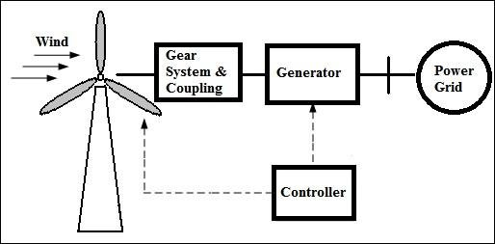

Figure 1.1: Block Diagram of Wind Power Plant

There are physical methods, mathematical methods, learning methods and combinations of these three wind power forecasting methods. Different methods are used for different time scales for different data sources. Mathematical and numerical methods are used based on historical data in the temporal prediction of wind power within six hours. Any one of these three methods can be implemented based on the Numerical Weather Prediction (NWP) forecast number numerical weather prediction (NWP) within forty-eight hours. Physical methods aim to describe the physical process of converting air into energy and models all the steps involved. The mathematical methods aim to explain the connection between wind estimation and power output directly through statistical analysis of time series from previous data. The most common mathematical methods are the time series method, the computational analysis method and the Kalman filtering method etc. Learning methods use an input technique that is able to precisely describe the most complex and complex relationships between input data and output data. In [6], wind speed and power were predicted by the neural network based on time series, but the effect was not negative on the long scale. The neural input network Artificial Neural Network (ANN) for wind power prediction was constructed based on NWP data to predict error rate.
An in-depth study of the development of an artificial neural network. Especially when AlphaGo defeats someone, the field of artificial intelligence has cleared up waves of deep learning. Deep learning is in line with the tendency of big data and has a strong and general reading ability of big data. This paper studies the wind power estimation model based on Long-Short-Term Memory, one of the deep learning algorithms. Practical information showing the characteristics of the wind farm is released by the PCA. The main features are selected as input of the LSTM(Long Short Term Memory) forecasting model. Training and learning the LSTM model based on a large number of climatic forecasting data.

Chapter 2

Evaluation Of Parameters Affecting Wind Turbine Power Generation
…………………………………………………………………………………………..

The wind turbine receives its input of energy by converting the wind energy into torque (variable power) operating on rotor blades. The amount of energy that the air transmits to the rotor depends on the size of the air, the rotation area, and the speed of the wind and the height of the tower. Various parameters can affect the performance of wind turbines namely: wind speed, wind pressure, temperature and blade height for wind generators.

  - PARAMETERS THAT AFFECT WIND POWER

There are following parameters that affect the wind power:

    - WIND SPEED AND CONSISTENCY:

Higher wind speeds produce more power because they allow distances to rotate faster. This rotation translates into additional mechanical power and more electrical power from the generator.
"The location of the installation is very important and should have normal wind speed, wind maps are used to determine if the location is right," Mr Leon Gouws said.
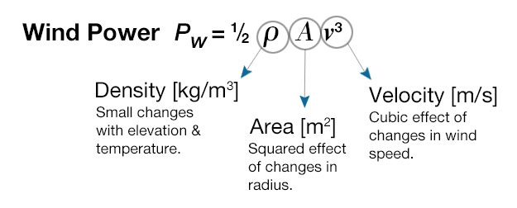

Since different regions have different wind speeds, the study of any proposed site is largely done to ensure a good return on investment. Wind speed is usually measured by a year at the site before any decision is taken.We can compile the available data for wind conversion and use a model such as Webull Distribution to calculate how well the wind of a particular region will operate.

    - HEIGHT OF TOWER AND INSTALLATION:

The speed of the air depends on the height of the turbine from the ground. At ground level, there are many obstacles in the form of buildings, houses, trees, etc. They restrict air movement and therefore slow down their speed. According to Eve already, wind turbines need to be installed on site where it is clear from the barrier to allow clean air flow, and emphasizes the importance of tower height in ensuring power flow.

“Generally increasing the height to 6 m will increase the wind speed by 0.5 m / s. Thus the outflow of an air turbine at a height of 24 m will be higher than that at the 12 m tower. "
Repeating the height of the tower is almost twice the airflow capacity. In addition, the highest altitudes are highly atmospheric due to the various atmospheric factors.

    - DENSITY OF AIR:

Wind power is directly proportional to the amount of air. The power output of turbines is related to the atmospheric density, which is a function of altitude, pressure and temperature. Gentle air has a great deal of pressure on the rotors, which results in high power output
Air pressure is high at sea level. That is why we have so many wind farms near or near the sea or the sea .In the high altitude, the area of ​​the wind is very low, so the wind farms are not made in the mountains.

    - ROTOR DIAMETER:

The power output of the air is directly proportional to the position of the rotor. Since the area is equal to twice the diameter, this means repeating the rotor diameter will also generate electrical energy. The turbine rotors are affected by two different forces: torque, which converts the rotors and creates power, and stiffness, which forces the turbine. Dealing with thrust can be difficult when designing a rotor.

    - TRENDS AND TECHNOLOGICAL BREAKTHROUGHS:

While wind power has decreased by ten times our current energy consumption, the overall effect in Africa is still below average. To overcome this challenge, innovative technologies have been used to generate wind power. As a result of this the energy output of the air has increased - and as a result, turbines are still more efficient, efficient and less expensive for the power producer. "There are some general changes to the blade design to improve the speed of the wind turbine engine to provide power at extremely low wind speeds,"

  - WIND TURBINE PARAMETERS THAT AFFECT WIND POWER:
There are many wind turbine’s parameters that affect the wind power:
    - CHOICE OF THE PITCH ANGLE:

The pitch angle is given by
α=I-i
(Where I is the angle between the speed of the wind stream and the speed of the blades and “i” is a constant.)

Now as I vary the length of the idi, α, it should also vary to ensure the correct angle of incidence at all points of the sphere. Therefore, the desired twist on the side of the stain can be easily calculated. This method produces a curved stain that has different angles at different distances from the axis.

    - TIP SPEED RATIO:

The tip speed ratio (TSR) of a wind turbine is defined as,

λ= 2πRN/V∞

where, V∞ = Speed of Wind without any rotor intervention
R=Radius of the Rotor, which signifies the swept area
N=Rotational speed of the rotor in rps
λ = Tip Speed Ratio

    - COEFFICIENT OF POWER

The power density (Cp) of the wind turbine basically indicates the efficiency of converting the wind power of the wind into mechanical power, the same ones used to drive the generators. Cp is cofactor that affect the out power.

    - TORQUE SPEED CHARACTERISTICS

Now we know that the Torque and power curves are related as follows:
Tm= Pm/ω;

Using the above value for

Pm=0.5Cp π (R⁵ / λ³) ω ³ ρ

We have,
Tm= Pm/ω;

Tm=0.5Cp π (R⁵ / λ³) ω ² ρ

Where
Tm : Mechanical torque
Pm : Output power
R : Radius
ω : Turbine speed
λ : Tip Speed Ratio
Cp : power density ()
ρ : Air density

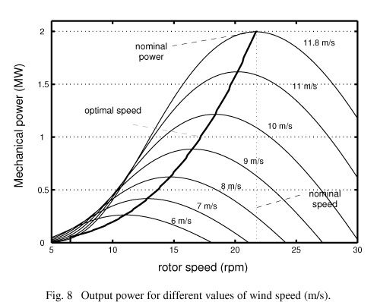
Figure 2.1: Output power for different value of wind speed(m/s)

Chapter 3

Forecasting Approaches
…………………………………………………………………………………………..

As the share of wind power in the power network continues to increase, it will challenge the safety and stability of the power network and reduce the rate of wind power development. Accurate wind power forecasting can effectively reduce or avoid the negative effects of wind farm on the power network. And it is very important for the sustainable development of wind power. There are physical methods, mathematical methods, learning methods and combinations of these three wind power forecasting methods. Different methods are used for different time scales for different data sources. Mathematical and numerical methods are used based on historical data in the temporal forecast of wind power within six hours. Any one of these three methods can be implemented based on the NWP forecast number (NWP) within forty-eight hours. Physical methods aim to describe the physical process of converting air into energy and showing all the steps involved. The mathematical methods aim to explain the connection between wind estimation and power output directly through statistical analysis of time series from previous data. The most common mathematical methods are the time series method, the computational analysis method and the kalman filtering method etc. Learning methods use an input technique that is able to precisely describe the most complex and complex relationships between input data and output data. In, wind speed and power were predicted by a neural network based on time series, but the effect was not negative on the long-term scale. As a model the neural input network (ANN) for wind power estimation was developed based on NWP data to predict error rate. An in-depth study of the development of an artificial neural network. Especially when AlphaGo defeats someone, the field of artificial intelligence has cleared up waves of deep learning. Deep learning is in line with the tendency of big data and has a strong reading ability for general access to big data. This paper studies the wind power estimation model based on Long-Short-Term Memory, one of the deep learning algorithms. Practical information showing the characteristics of the wind farm is released by the PCA. The main features are selected as input of the LSTM forecasting model. Training and learning the LSTM model based on a large number of climatic forecasting data.

  - LONG SHORT-TERM MEMORY

Long Short-term Memory (LSTM) is a deep learning method proposed in 1997 by Sepp Hochreiter and Jürgen Schmidhuber. Deep learning is a branch of machine learning based on a set of algorithms that try to simulate the maximum output of data using a deep graph with multiple layers of processing, compounded by unequal linear regression and inequality. Compared to the traditional shallow model, it has many layers of uneven convergence, creating conditions for measuring complex operations. With enough training samples, an in-depth learning model can reach full potential and extract a large amount of information contained in large databases. LSTM can be used as a complex nonlinear unit to build a large deep neural network, which can show the effect of long-term memory and has the ability to learn deeply. The LSTM network consists of an input layer, an output layer, and a range of hidden layers. The hidden layer is formed by the memory cell, the basic structure is shown in Fig. 2. Each cell contains three gates (input, forget, output), and a multiplicative communication unit. The input to this unit is xt, the current input in step t, and st, the current hidden state. Out of the current ot, ct is the unit's internal memory.
Long-term memory units (LSTM) (or blocks) are the building blocks of a common neural network (RNN). An RNN made up of LSTM units is often referred to as an LSTM network. The standard LSTM unit is composed of a cell, an input gate, an output gate and a forgotten gate. The cell is responsible for remembering "values ​​at regular intervals; that's why the term" memory "in LSTM. of a weighted sum. Conversely, they can be considered as controllers for the flow rates of LSTM connections; that is why a gate means "gate". There is a connection between these gates and the cell.

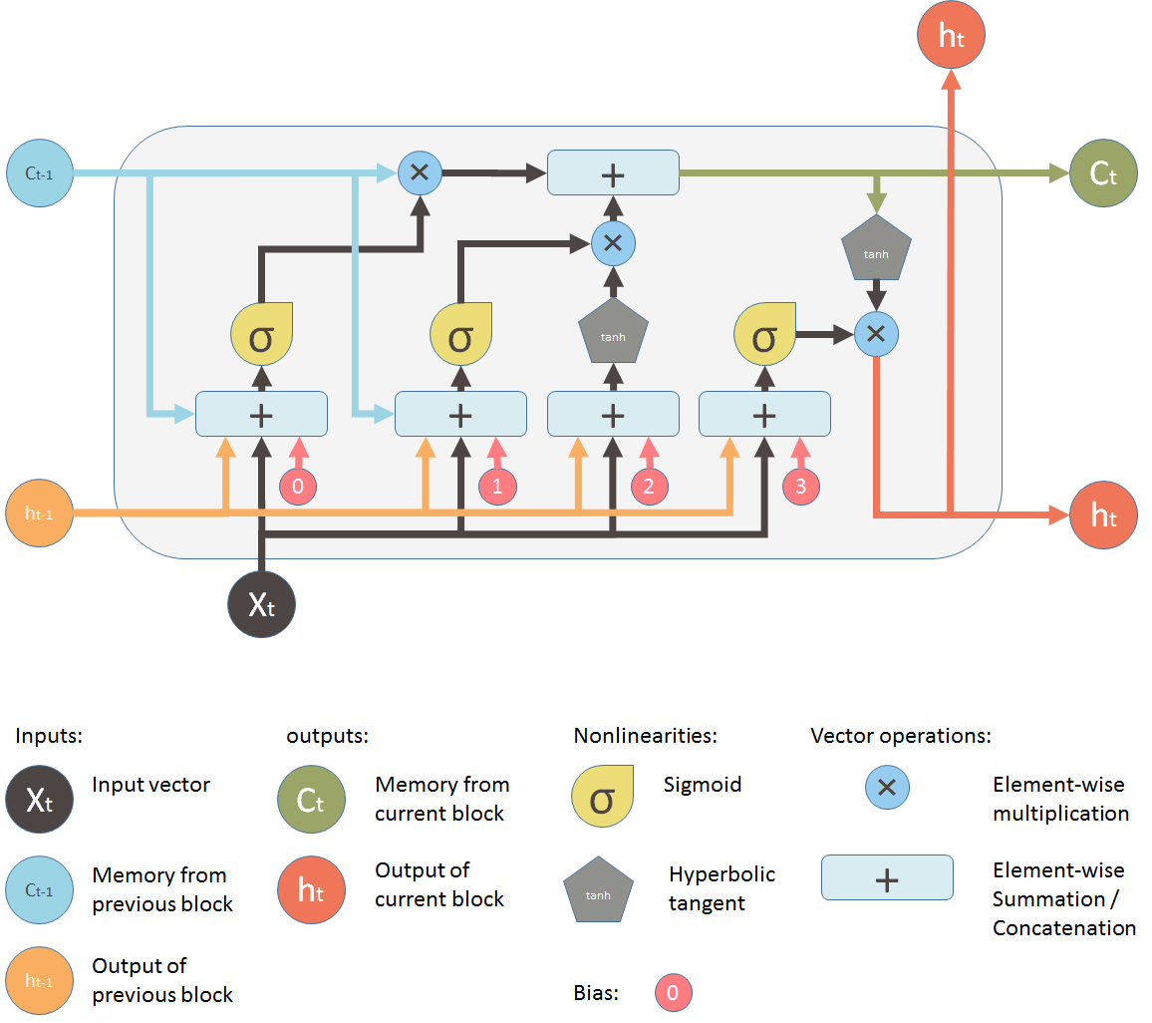

Figure 3.1: LSTM model

Gates use a sigmoid activation (denoted by g), while input and cell state are often transformed with tanh. LSTM cell can be defined with a following set of equations:

Input gate: it = g(Wxi xt +Whist −1 + bi )
Forget gate: ft = g(Wxf xt +Whf st −1+ bf )
Output gate: o = g(Wx +W s + b )

Input transform: c _ in = tanh(W x +W s + b )
State update: ct = ft ⋅ ct −1 + it ⋅ c _ int st = ot ⋅ tanh(ct )

where Wij is the connection weights of neuron i to j, b is deflection.

The number of hidden layers and the number of neurons in each layer play an important role in neural network training and influence the prediction accuracy. The more the number of hidden layers and neurons in each layer, the more complex the model becomes. If there are only a few neurons in each layer, the network may not be trained or the operation is wrong. In the case of many neurons, although the network error can be reduced, but on the other hand, the network training time is longer and the training can occur with greater frequency.

  - LSTM PREDICTION MODEL:

The historical wind power data and NWP data are selected as samples of the prediction model. According to the network structure shown in Figure 3, the model can be expressed as follows:

o(t +1) = F (o(t), o(t −1),……., o(t − n),
x(t +1), x(t), x(t −1),……,x(t − n)

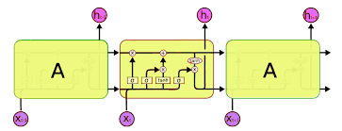

Figure 3.2: LSTM block chain diagram

The network topology of the LSTM forecasting model is shown in Fig. 4. In this paper, a three-layer hidden layer LSTM network has been developed. After analysis of the main component of the actual NWP data, the two main components that have the greatest influence on wind power are obtained as input to the forecast model. And the power of the wind farm is to take out the model.

Chapter 4

Simulink Block Diagram Of Wind Power Generator
…………………………………………………………………………………………..

Simulation block diagram of wind poer generator:
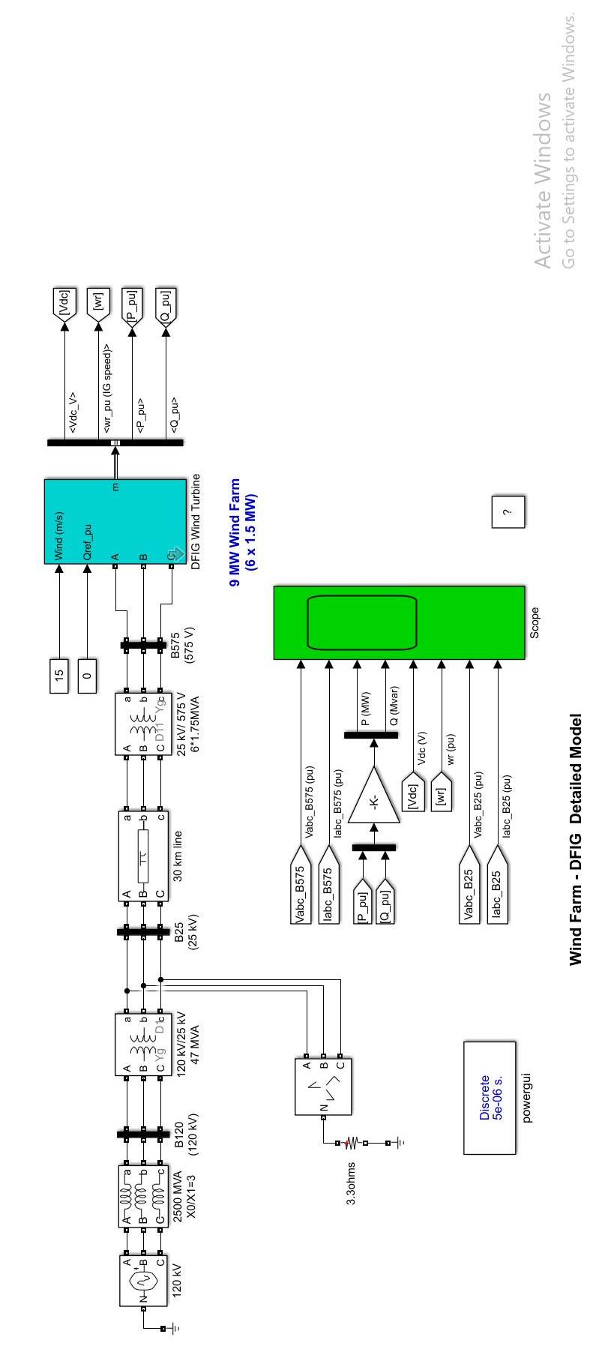

Figure 4.1: Simulation diagram of DFIG turbine

Output:

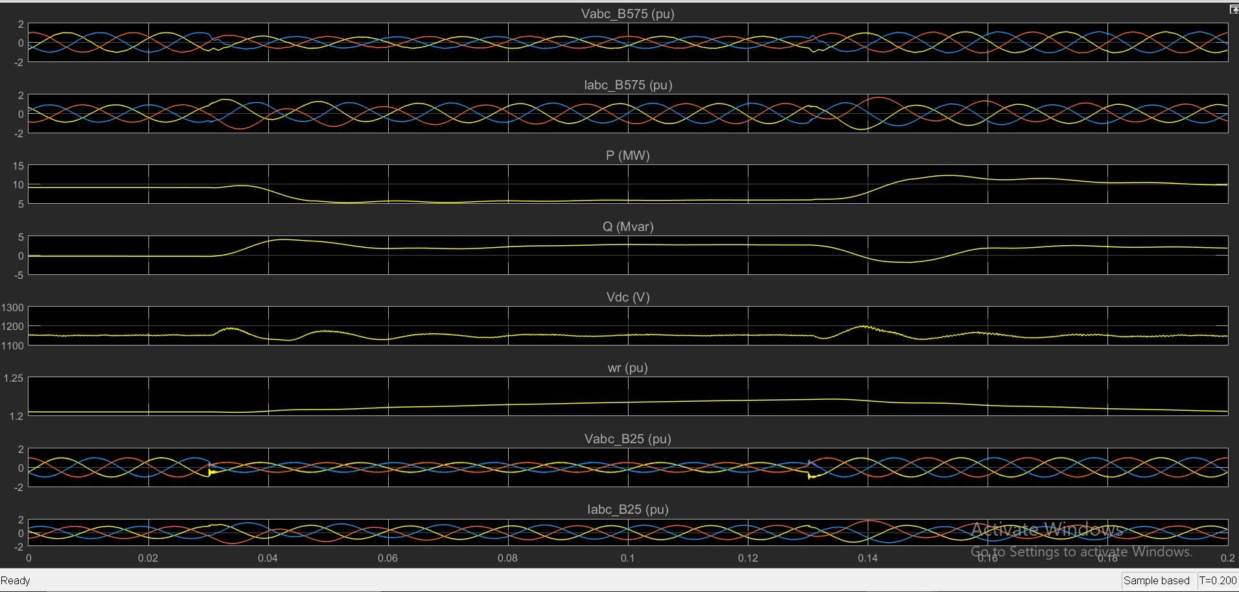

Figure 4.2: Current, Voltage and output power of simulation

Chapter 5

Data-Set For LSTM Experiments:
…………………………………………………………………………………………..

6 years of wind energy data is used in my project. The data after the preliminary analysis contains details about the time intervals, air temperature (C), pressure (atm), wind direction (deg), wind speed (m / s) and power generated by the system (kW). We have had hourly data for about 6 years.

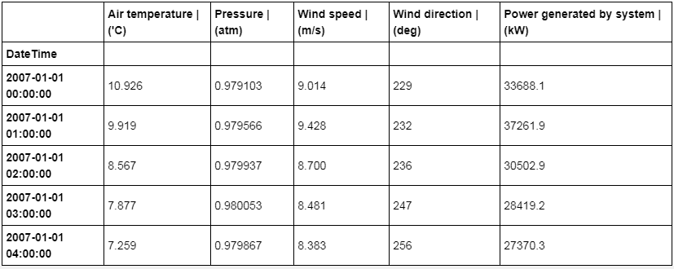

Table 5.1 Data Snapshot

All the features are used for Estimation model and only time-series features i.e. Date Time and power generated by the system are used for prediction experiments.

Chapter 6

Results And Plots Of Computation:
…………………………………………………………………………………………..

  - ESTIMATION:

The whole equation is about guessing the power of the wind given the current wind direction. Given the current wind and temperature conditions, this simplifies the problem with a LSTM-like model that looks at current weather and past weather conditions to predict the energy generated by the system. Predictability in the LSTM prediction series by the Keres library was used for this. After doing the basic model and initial testing we found that an 8-point backdrop is a very good number that gives important results in the forecast. Estimation models are useful when we get weather information about the current day or the future publicly using machine learning with some precision. Subsequently this model is used to be a complete estimate of the energy produced by the system.

    - 70-30 TRAIN TEST BATCH

Six years of hourly data are separated by a 70-30 train test board for this test. That means 4 years of data has been used to predict 2 years of wind generation.

square root error (RMSE) = 1.242
Variance = 0.984

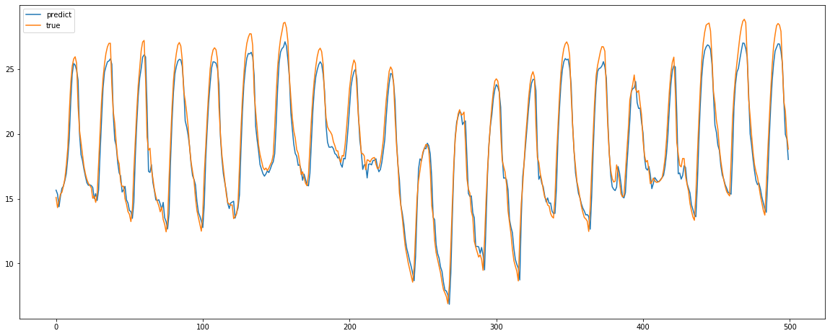
Figure 6.1: Data estimation for 70-30 ratio

    - 60-40 TRAIN TEST BATCH
Six years of hourly data are separated by a 60-40 train test board for this test. That means 3 years of data has been used to predict 3 years of wind generation.

square root error (RMSE) = 1.667
Variance = 0.969

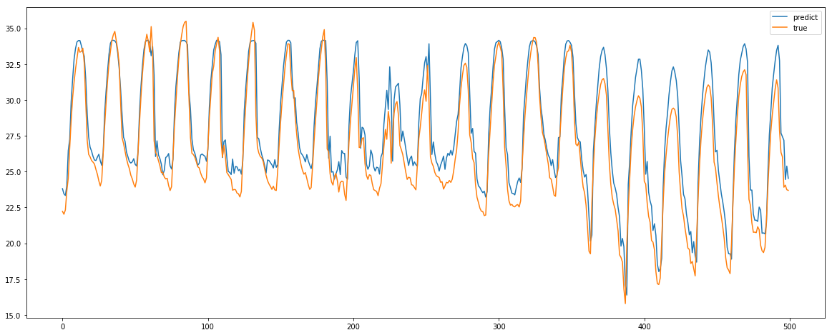

Figure 6.2: Data estimation for 60-40 ratio

  - PREDICTION USING ONE BY ONE POINT:

In the forecast section, we predict the energy generated by the system without any knowledge of future weather. This is important because forecasting future weather is also a different problem for machine prediction by learning about its different challenges. We will never know what the storm surge will be or what the temperature or pressure will be in the future. Therefore, we try to predict the power only by analyzing the pattern in the previous data using LSTM. The data in this model will be the Date Time and Power generated by the program in the target format as required by LSTM The LSTM will analyze the previous data and try to obtain useful information about the patterns in the previous data. And using that information will predict results. Forecasts are used to predict future prices and to evaluate results.
After performing the basic LSTM model, we performed many different experiments to get the best look back with the neurons required by the LSTM. After obtaining a retrospective look, the number of neuron and other specific parameters is correct in the model for which we performed a few experiments and predictions. Their effect is as follows.

LSTM MODEL CONFIGURATION:
Input Batch Size = 1
Epochs = 7
No. of Neurons = 10
Look Backs/lag = 24

    - PREDICTION OF 12 HOURS

12 hours data was predicted with the same model configurations.

Mean percent error = 18.28%.

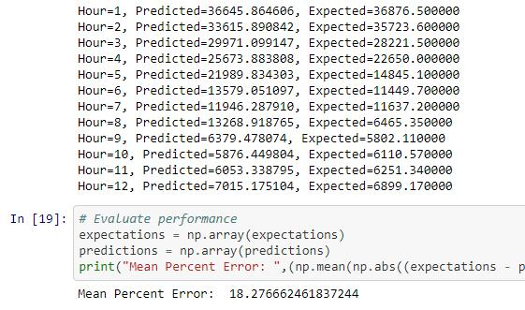

Plot diagram:

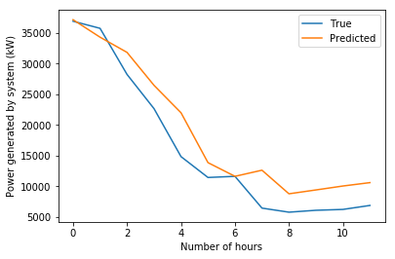

Figure 6.3 Power prediction for 12 hours

    - PREDICTION FOR 24 HOURS

24 hours data was predicted
Mean percentage error = 24.53%

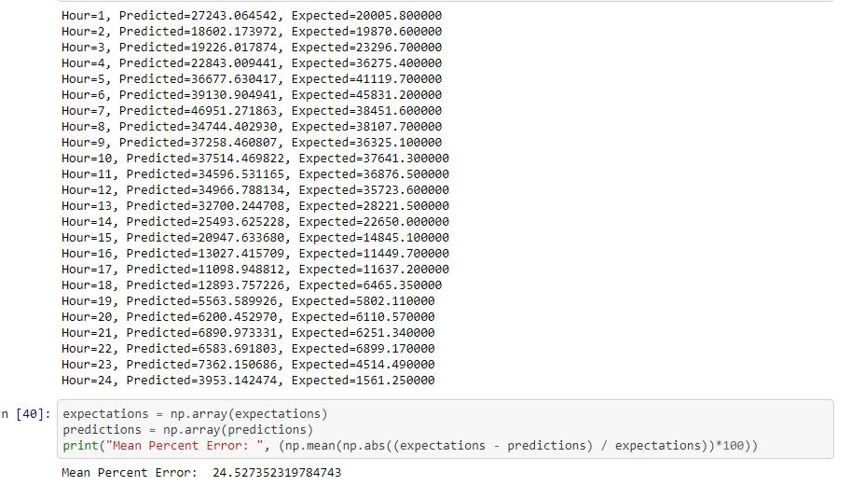

Plot diagram:

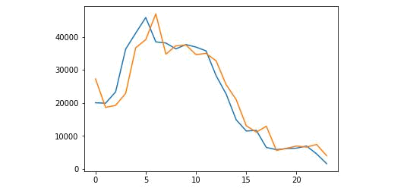

Figure 6.4 Power prediction for 24 hours

    - PREDICTION FOR 48 HOURS

48 hours of data was predicted
Mean percentage error = 39.47%

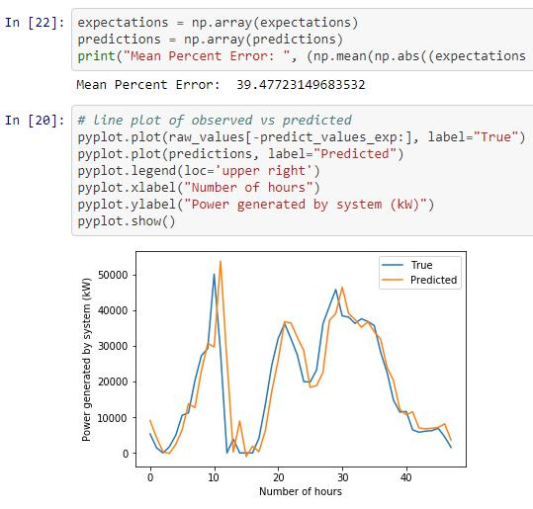

Figure 6.5: Power prediction for 48 hours

    - PREDICTION FOR 1 WEEK

1 weeks data was predicted
Mean Square Error = 44.74%

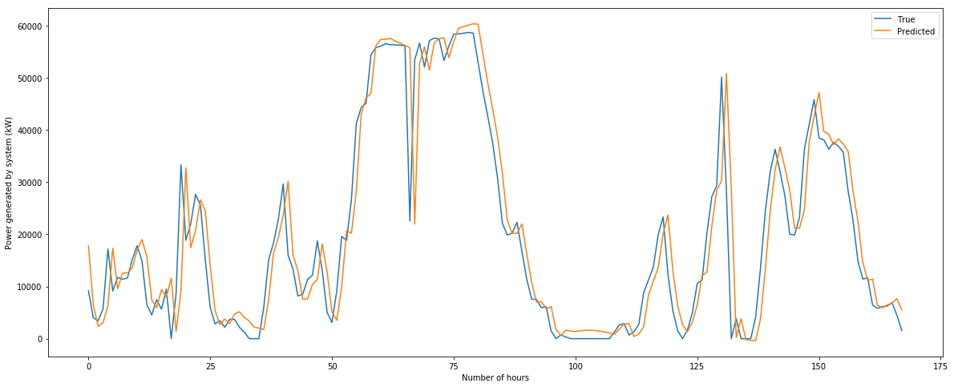
Figure 6.6: Power prediction for 1 week hours

    - PREDICTION FOR 12 HOURS WITH MODEL OPTIMIZATION

12 hours data was predicted
Mean Square Error = 15.996%

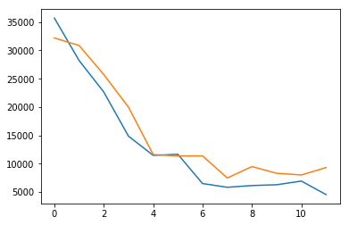

Figure 6.7: Power prediction for 12 hours with more accuracy

    - PREDICTION FOR 48 HOURS WITH MODEL OPTIMIZATION

24 hours data was predicted
Mean Square Error = 30.766%

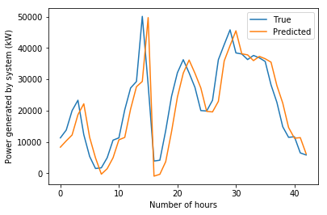

Figure 6.8: Power prediction for 24 hours with more accuracy
    - PREDICTION FOR 1WEEK WITH MODEL OPTIMIZATION

48 hours data was predicted
Mean Square Error = 38.634%

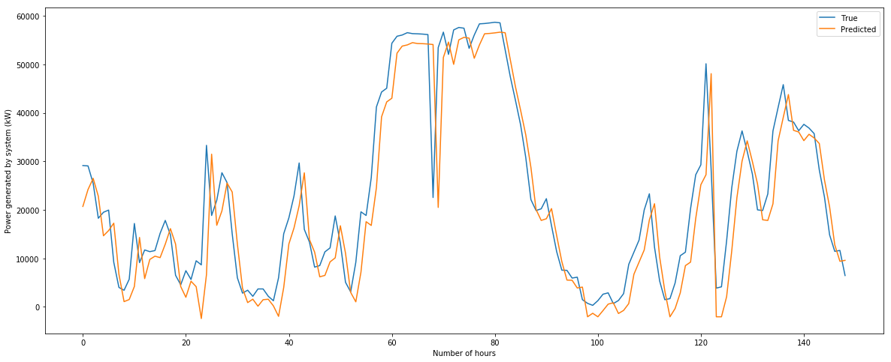

Figure 6.9: Power prediction for 48 hours with more accuracy

  - POWER PREDICTION FOR NEXT KTH TIME INTERVAL AT A TIME.

    - POWER PREDICTION FOR NEXT 24 HOURS

Mean Absolute Percent Error = 35.143%

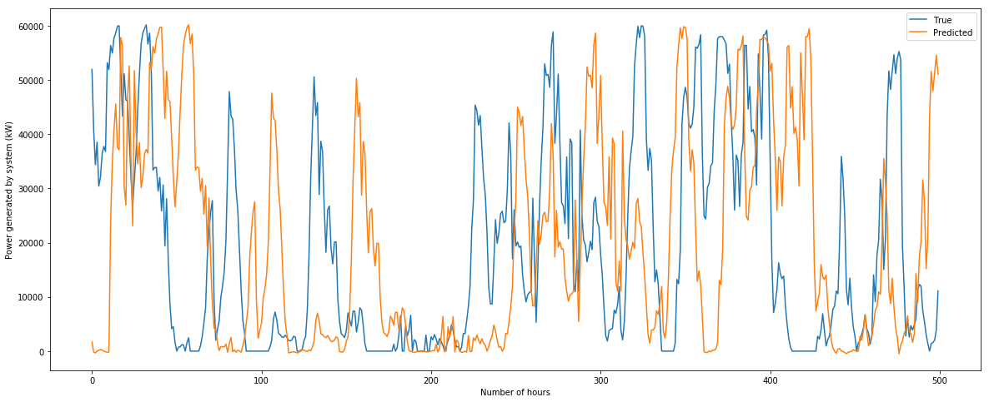

Figure 6.10: Power prediction for 24 hours

    - FUTURE POWER PREDICTION FOR NEXT 48 HOURS

Mean Absolute Percent Error: 46.716%

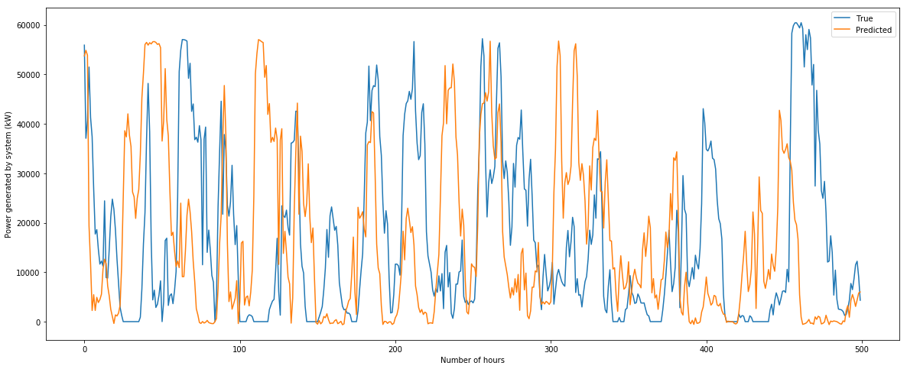

Figure 6.11: Power prediction for 48 hours

    - FUTURE POWER PREDICTION FOR NEXT 1 WEEK

Mean Absolute Percent Error: 51.473%

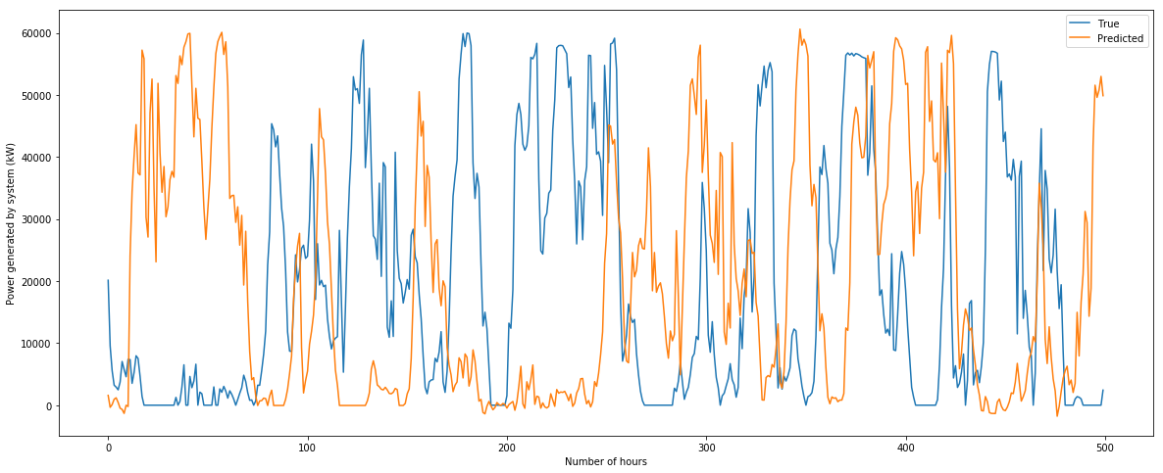

Figure 6.12: Power prediction for 1 week

    - FUTURE POWER PREDICTION FOR NEXT 1 MONTH

Mean Absolute Percent Error: 59.906%

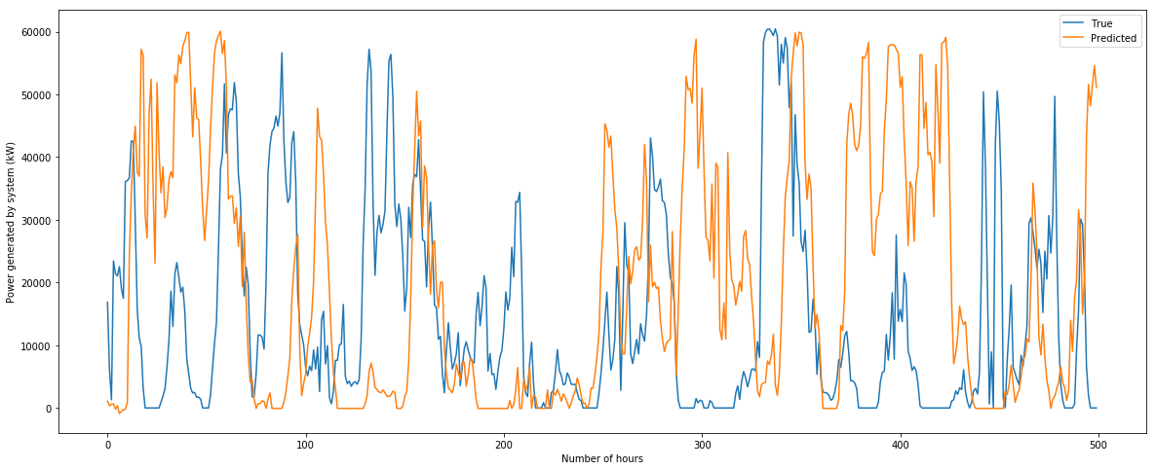

Figure 6.13: Power prediction for 1 month

In all of the above experiments in the linear graph we can see that LSTM is able to read the pattern from the data very well and consequently give some good long-term results in balance as the monthly forecast.
After that the LSTM model is optimized as increasing the input batch size to control the weight updates to the model, adding additional hidden layers such as Batch Normalization and Dense layer with various optimization functions such as ‘rue’ and ‘tanh’.

Chapter 7

Front End Design:
…………………………………………………………………………………………..

Python offers many options for developing a GUI (Graphical User Interface). Of all the GUI modes, tkinter is the most widely used method. Tkinter is actually a Python-built module used to create simple GUI applications. It is the most used module for GUI applications in Python. The standard Python interface in the Tk GUI for Python tools is exported. Python with tkinter provides a fast and easy way to execute GUI programs.

  - FUNDAMENTALS OF TKINTER

Consider the following diagram, it shows how an application actually executes in Tkinter:

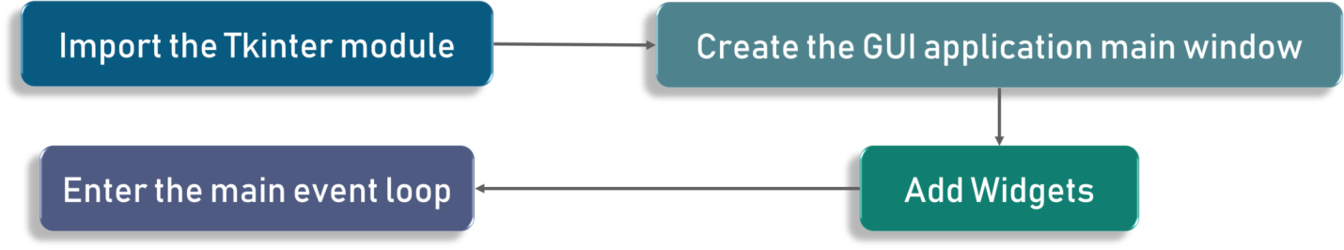

Figure 7.1: block diagram for Creating a GUI using tkinter

Creating a GUI using tkinter is an easy task.
To create a tkinter:
1. Importing the module – tkinter
2. Create the main window (container)
3. Add any number of widgets to the main window
4. Apply the event Trigger on the widgets.

Importing tkinter is same as importing any other module in the python code. Note that the name of the module in Python 2.x is ‘Tkinter’ and in Python 3.x is ‘tkinter’.

import tkinter
An event loop is basically telling the code to keep displaying the window until we manually close it. It runs in an infinite loop in the back-end.
Check out the following code for better clarity:

1. import tkinter
2. window = tkinter.Tk()
3. # to rename the title of the window window.title("GUI")
4. # pack is used to show the object in the window
5. label = tkinter.Label(window, text = "Hello World!").pack()
6. window.mainloop()

  - TKINTER WIDGETS

Widgets are just like things in HTML. You will find different types of widgets in various types of objects in Tkinter. Let's see a brief introduction to all these widgets in Tkinter. Check out this sketch for a list of the most commonly used Tkinter widgets:

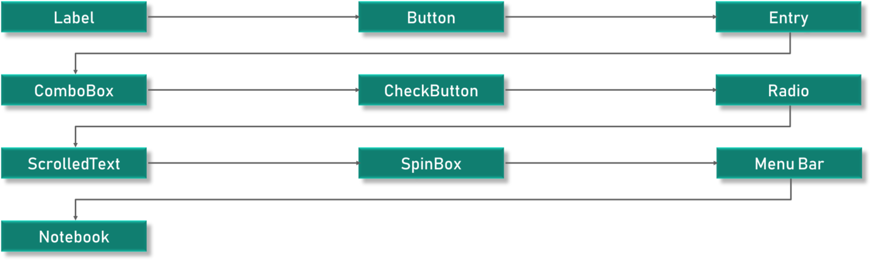

Figure 7.2: block diagram for Creating a Tkinter Widgets

1. Canvas – Canvas is used to draw shapes in your GUI.
2. Button – Button widget is used to place the buttons in the Tkinter.
3. Checkbutton – Checkbutton is used to create the check buttons in your application. Note that you can select more than one option at a time.
4. Entry – Entry widget is used to create input fields in the GUI.
5. Frame – Frame is used as containers in the Tkinter.
6. Label – Label is used to create a single line widgets like text, images etc.
7. Menu – Menu is used to create menus in the GUI.

These widgets are the reason that Tkinter is so popular. It makes it really easy to understand and use practically.

  - LABEL WIDGET:

As mentioned earlier, labels are used to create texts and images and all of that but it is important to note that it has to be a single line definition only. Here’s the code snippet:

1. l1 = Label (window, text="edureka!“ font=("Arial Bold", 50))
2. l1.grid (column=0, row=0)

We have entered our text as Edureka and that is printed as it is.

FRONT DESIGN OF THE PROJECT:

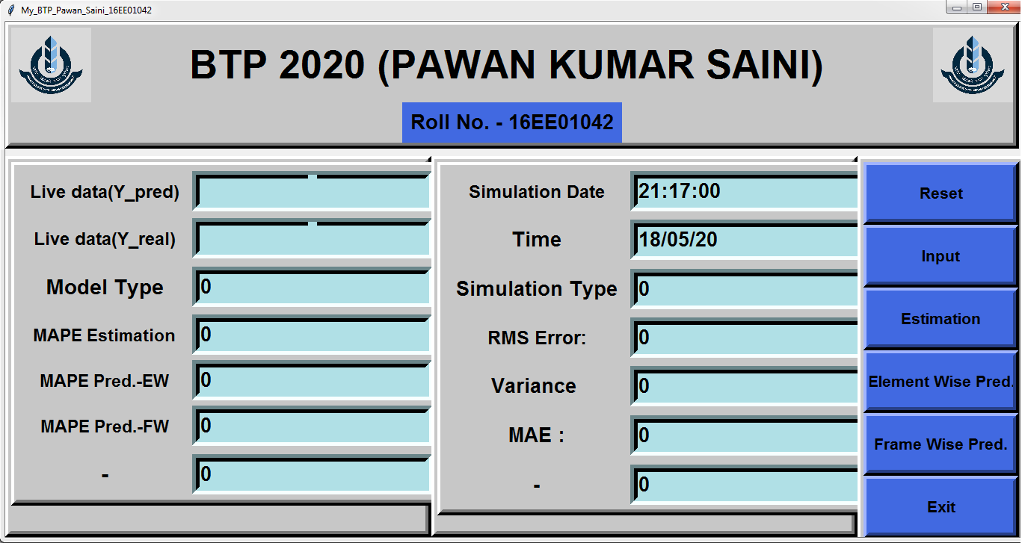

Figure 7.3: Front End View of Project

  - BUTTON:

Reset: Reset button is used to reset the all data and screen
Input: Input button is used to take the input for training and testing of data.
Estimation: Estimation is used for estimation of dataset using LSTM forest model.
Element Wise Pred.: Element Wise Pred. button is used for predicting the future power using element wise method using LSTM model.
Frame Wise Pred.: Element Wise Pred. button is used for predicting the future power using frame wise method using LSTM model.
Exit: Exit button is used to exit the open window.

  - BLOCKS:

Live data(y_pred): This block is used to display the predicted result of the current index of testing dataset.
Live data(y_test): This block is used to display the result of the current index of labeled testing dataset.
Date: This block used to display the date.
Time: This block used to display the time.
Model: This block used to display the Type of model like LSTM.
MAPE Estimation: This block used to display the Mean Absolute Percentage Error of the testing dataset.
MAPE Pred.-EW: This block used to display the Mean Absolute Percentage Error of the testing dataset using Element wise prediction using LSTM model.
MAPE Pred.-FW: This block used to display the Mean Absolute Percentage Error of the testing dataset using Frame wise prediction using LSTM model.
Simulation Type: This block used to display the Type of model like Estimation or Prediction..
RMS Error: This block used to display the Root Mean Squared Error of the testing dataset using LSTM model.
Variance: This block used to display the Variance of the testing dataset using LSTM model.
MAE: This block used to display Mean Absolute Error of the testing dataset using LSTM model.

Chapter 8

Conclusion
…………………………………………………………………………………………..

The capacity to increase wind speed over the past 15 years has made progress in wind forecasting techniques. Improvements in facilities in the NWP, driven by advances in the acquisition and acquisition of computer power, have led to greater accuracy by eliminating the use of extra features and services. Continuing to innovate with mathematical and machine learning techniques has also paid dividends, especially for the call of the shorter and shorter time periods. Hybrid methods bring some of the benefits of both NWPS (time-sensitive accuracy measures) and machine and machine learning techniques (subject to better time resolution and better air-quality representation at the local scale). They have changed future developments in wind forecasting technologies, and current plans to significantly increase sea air capacity do not require model upgrades in this area.
We noticed that LSTM was able to detect a pattern in longitudinal data i.e. annual and annual changes in the energy generated by the system. And its performance is similar to that of SVM and AR systems. However, we also found that if the wind speed is less than 4 m / s the power generated by the system is zero. LSTM could not read this pattern as this is not a part that can be understood in the time series analysis. Therefore, with the creation of a new hybrid model that can serve as a combination of Decision Tree / Random Tree and LSTM we can optimize these results.

Chapter 9

Current Research Activities And Future Advances
…………………………………………………………………………………………..

The majority of wind power forecasting models study 'generalized wind conditions'. The EU-sponsored project called 'Safe wind' aims to improve wind power forecasting during challenging and adverse weather conditions and at various spatial scales. Development activities will still reduce error in forecasting wind power, improve wind forecasts by offshore wind farms, and methods for obtaining wind forecasting for offshore wind farms. It is possible that the use of integrated and integrated climatic methods together may enhance the forecast. If the error of wind forecasting and forecasting is reduced electric markets can sell with greater certainty. Contractors as a part-time contractor in the electricity market can rise to 39% of the lead time of 4 h. Gubina et al. (2009) [63] introduced a new tool called WILMAR and ANEMOS scheduling method (WALT) to reduce the number of thermal generators when stopping or booking using generation outputs and dispersion capacity by system-dependent methods instead of generating the output based solely on generation. Climate and load errors are calculated using the Gaussian transition method. However, in one study, it was found that the prediction errors are no longer sufficient for the Kolmogorov-Smirnov test for normal distribution. In Ramìrez and Carla, it was shown that the use of auto correlated (and therefore not independent) hourly mean wind speed, or it could perform all standard statistical tests, had no significant effect on the estimated pdf format from the data. Offshore wind farms are challenging based on strong wind forecasts because the environment is normal and smooth with very few obstacles and so the change in wind speed and thermal effects sounds more obvious than in the global climate.
Let’s discuss some of the issues associated with forecasting offshore wind farms, including:
- Current forecasting and prediction models are designed for on-shore environment and still have errors,
- Resource assessment is difﬁcult due to completely different conditions, offshore is vast, ﬂat and smooth (with a variable roughness) and thus weather fronts are felt more acutely than on land. Therefore thermal effects, wake affects and coastal land mass effects are ampliﬁed.
- Poor availability of meteorological data to validate NWP outputs for these offshore locations
Current indicators of excellent performance include adapting existing models and using CFD optimized marine environments. To illustrate the false assumptions of accurate estimates of offshore wind, the current cast '(e.g. time time wave) is included in Fig. for comparative purposes, and it can be seen that the RMSE exceeds that of many coastal statistical assumptions.

Bibliography

- 2016 IEEE PES Asia-Pacific Power and Energy Conference - Xi'an – China “Short-Term Prediction of Wind Power Based on Deep Learning-Long Short-Term Memory” Qu Xiaoyun, Kang Xiaoning, Zhang Chao, Jiang Shuai, Ma Xiuda Shaanxi Key Laboratory of Smart Grid, Xi'an Jiaotong University

- “A Combined Approach for Very Short Term Wind Power Probability Forecast” -
Yubo Tao, Yafei Zhang, Bo Chen and Jing Shi, Member, IEEE

- https://www.analyticsvidhya.com/blog/2017/12/fundamentals-of-deep-learning introduction-to-lstm/

- https://www.kaggle.com/jphoon/bitcoin-time-series-prediction-with-lstm

- https://machinelearningmastery.com/time-series-forecasting-long-short-term-memory-network-python/

- https://en.wikipedia.org/wiki/Long_short-term_memory

